**Database Iteration 3 Plan**

This iteration was more about me fixing and tidying up tasks in the other iterations. Mainly data types and security. In this iteration I am going to fix and add roles and permissions for the worker role and so patients can view their own data. For datatypes there were a couple that didn’t make much sense, or I over thought how many characters they would need. Also, I’m going to be adding more testing in this iteration just to check if anything issues pop up.

**Security**

Updated worker role so they could now update, insert and select different databases. Did not give them permission to add new workers as it is not part of their job but allowed them to update information and insert new information for different tables. Made sure that they were able to delete information they no longer needed due to GDPR rules.

Ability for people to view their own data.

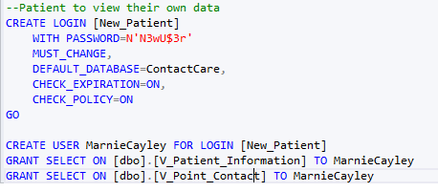

**Testing**

In this iteration I added more testing to the database so I would be able to view if the information would show up any errors.

**Changing datatypes**

* Phone numbers: When looking online I found the recommended datatype to be VARCHAR(15)
* Addresses: VARCHAR(15)
* Postcode: VARCHAR(4)
* IDs: Smallint

**Backup**

Created a backup for this iteration.

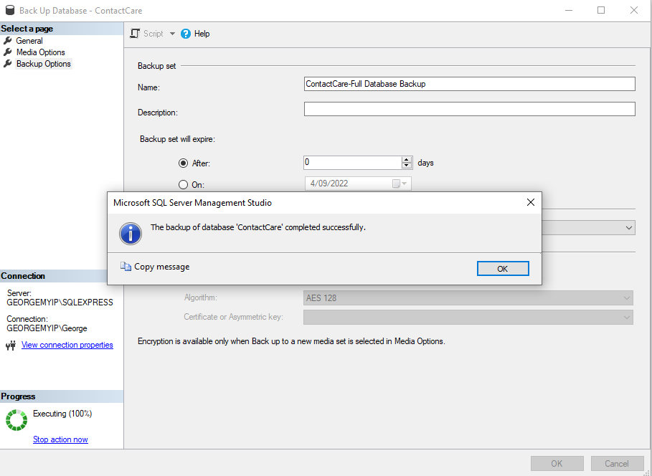

**Performance review:**

Having the to do list really helped me with this iteration. I was able to go down the list and do each task. I think that I should use it in the upcoming assignments to help me get started. During this iteration I started to use the freedom extension on chrome to try and not procrastinate as often. I did have a couple of issues of it not giving me access to things that I needed for the project, but I was able to work it out in the end.

During this assignment I started to do my work in 1-hour sprints and then take a break. I think that this was the thing that helped me the most. I found my self in other assignments that I would just crunch on the project near the end. But setting times during the day of having a 1-hour work time slot for only this project helped me.

This last iteration I did find myself doing a lot more work that I feel I should have got done in other iterations. This did make me jump from task to task. I wish I had got more done or fully completed tasks in the other iterations.